Template for Evidence(s)
UI GreenMetric Questionnaire

University : ...
Country : ...
Web Address : …
SAMPLE
[7] Governance and Digitalization (GD)

[7.20] LMS-Enabled Digital Literacy Program (GD.11)

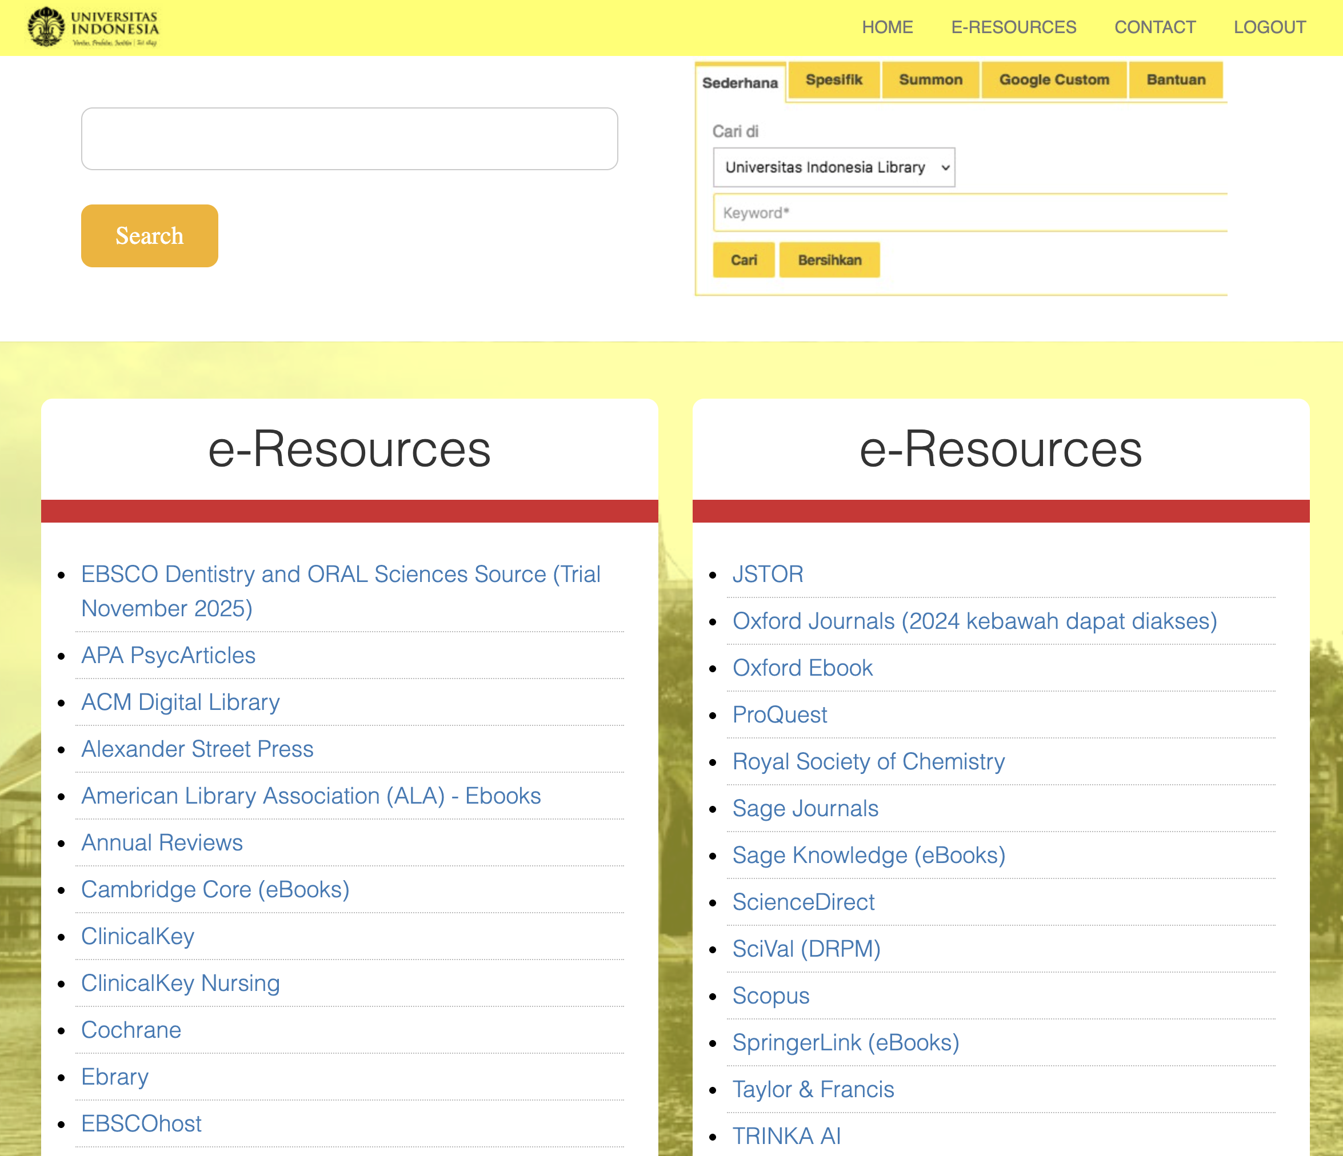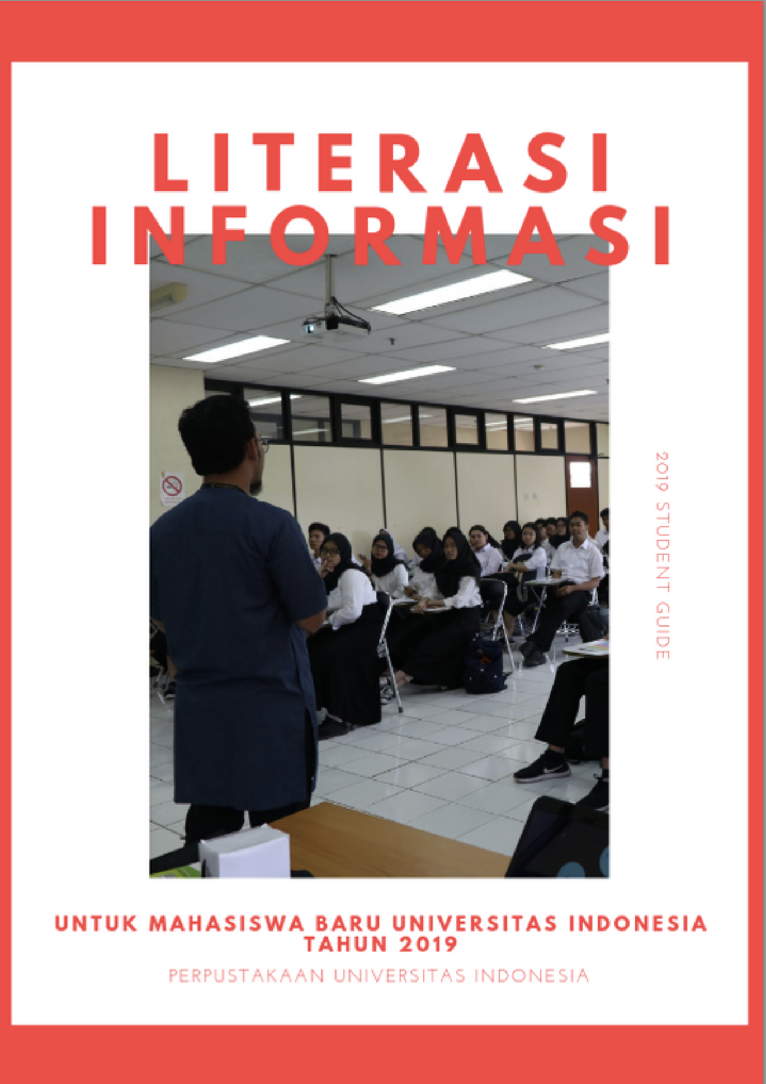
Example of Digital Literacy programs at Universitas Indonesia: remote access to subscribed digital libraries around the world; and information literacy introduction for new students

Description:
(Please describe the implementation of Digital Literacy programs at the University)

Digital literacy at Universitas Indonesia is implemented through coordinated programs led by different units. Programs conducted at Universitas Indonesia related to digital literacy:

1) New-student and baseline training
UI Library defines information literacy as a core academic competence covering critical evaluation of digital information, ethical use of sources, and plagiarism prevention.
Source: https://lib.ui.ac.id/unduh/unduh/Modul%20OBM%202019%20%28Literasi%20Informasi%29.pdf?id=1

2) Digital access and search skills
UI Library trains students and staff to use digital academic infrastructure, including OPAC, electronic databases, institutional repositories, and open-access resources.
Source: https://lib.ui.ac.id/unduh/unduh/Modul%20OBM%202019%20%28Literasi%20Informasi%29.pdf?id=1

3) Access to Digital Library Around The World
Universitas Indonesia operates digital literacy programs that provide remote access to subscribed digital libraries worldwide. The university gives students and staff secure off-campus access to journals, e-books, datasets, and academic databases.
Source: https://remote-lib.ui.ac.id/menu

4) Cybersecurity awareness with digital citizenship framing
Sekolah Kajian Stratejik dan Global UI implements cyber security awareness programs that integrate digital ethics, digital law, and digital literacy concepts.
Source: https://sksg.ui.ac.id/sksg-ui-gelar-pelatihan-cyber-security-awareness-cysa/

4) Structured cyber capacity building through idCARE.UI
idCARE.UI operates as a specialized center established with JICA support to strengthen cyber resilience and digital competence.
Source: https://www.idcare-ui.id/

Additional evidence link (i.e., for videos, more images, or other files that are not included in this file):

